Rational Rose Code Generation

Rational Rose has an option that allows you to generate source code that corresponds to your object model. When you generate source code, rational rose automatically creates the .h and .cpp files. Contained in these files will be the class shells. Rose generates the classes and adds the attributes to them. It also creates the methods with empty bodies. You must go in and add the body of the methods yourself.

The first step in code generation is creating or opening an object model.

You will next want to convert the classes on your diagram to ANSI C++.
To do this, you will select all of the classes on your diagram and go to the Tools menu. Under the Tools menu there is a submenu called ANSI C++. Underneath that menu is an option called “Convert from classic C++”. Select this option. Your screen will appear as follows:
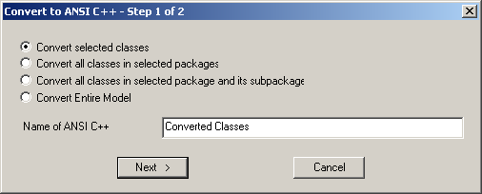
Click next. Your screen will then appear as follows:
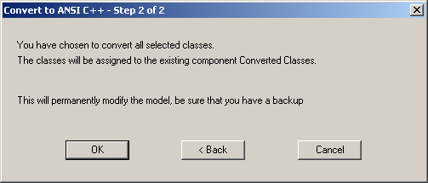
Click ok. You will now have a component called converted classes.

Once you have created the “Converted Classes” component, you must add the classes to the component. To do this, expand both the Logical View folder and the Component View Folder in the box on the left hand side of the screen. The following picture shows both folders expanded out
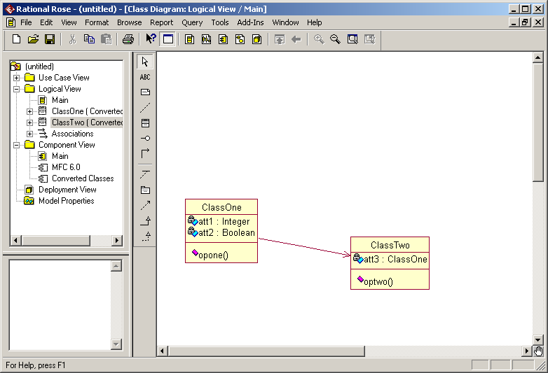

Once you have expanded the folders, you must add the classes to a component. To do this, click on the classes in your logical view folder and drag them to the “Converted Classes” component.

You are now ready to generate your code. To do this, you should right click on the “Converted Classes” component. You should then select “Generate Code…” from the ANSI C++ submenu. When you do this, the following dialog box will appear:
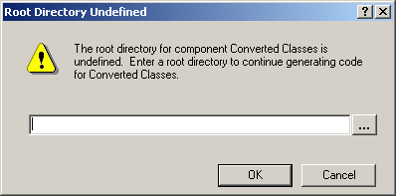
You should select the directory where you want the .h and .cpp files to be deposited and click OK. The following dialog box will appear:
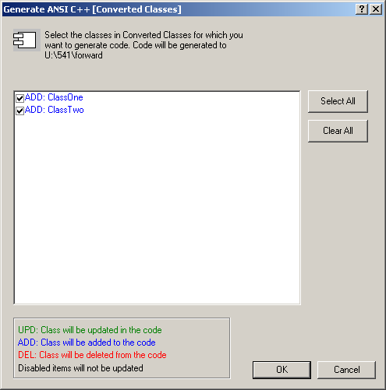

Click Select All and then OK.

You should then get a dialog box that says code generation is complete. You can now view the C++ code that was generated.

Assignment
First, follow the steps in this tutorial to create an object model that has at least two classes. Try to be creative. Think of what you want to represent with your model. Give a meaningful name to each class. Add necessary attributes and methods. Each class should have more than two methods and more than two attributes. Once you have completed the model, you need to generate code for that model. Once you have completed code generation, you should show the model and the generated code to the instructor.
Next, create a model that represents a binary search tree. You will probably have two classes, one to represent a node in the binary search tree, and the other to represent the binary search tree itself. Think what attributes and methods should be in each class. You will probably want to have a data attribute in your node class as well as left child and right child attributes. You will probably have to have a root attribute and an insert method and a print method in the binary search tree class. After you create a model, generate code and show both the model and the generated code to the instructor.
Last, add code to the methods of each class. Compile them. Make sure there are no compilation errors. Then, write a driver to test your classes. Show a couple of test cases to the instructor.

